**Drip Irrigation System**

**- By Nikhil Dugar(BT17GCS068)**

**Introduction:-**

To improve agricultural water resources’ utilization, crop’s automatic, locate, time and appropriate drip irrigation is a good choice. I will assume that temperature, soil moisture can be measured accurately and we have the amount of water required for different plants already listed in a fuzzy set like let’s say “Paddy plant” labelled as “High” etc. Another assumption we will have is that weather will have only 2 components – Temperature -which is a fuzzy set, Rain – which is a crisp set of yes and no. The latter part of the document covers the no rain condition as during rain we won’t use the pumping station. Moisture doesn't play a big enough part in water supply hence I'm not considering it. This might not reflect real conditions accurately.

We have 3 fuzzy sets – 1)Soil moisture

2)Temperature

3)Plant type

**Soil Moisture:-**

We are using soil moisture in percentage to define the membership values. If moisture <=10% membership value = 1 etc. The full table is defined below.

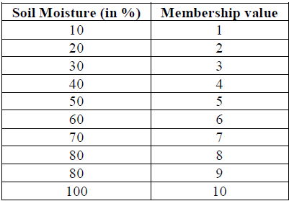

Using this table we define the following fuzzy membership:-

* Very Dry soil=(1,1,3) # Triangular membership function
* Dry soil = (2,2.5,4) # Triangular membership function
* Moist soil = (4,4.5,7) # Triangular membership function
* Wet soil = (6,6.5,8) # Triangular membership function
* Flooded soil =(7.5,8.5,10,10) # Trapezoidal membership function

**Temperature:-**

Temperature(in Celsius) Membership is as follows:-

* Very Hot = (40,50,60) # Triangular membership function
* Hot = (35,40,45) # Triangular membership function
* Moderate = (20,30,35) # Triangular membership function

**Plant Type:-**

We assume there are 3 categories of plants list given as fuzzy or crisp input– High amount water requiring plants, Low amount water requiring plants, Medium amount water requiring plants.

**Fuzzy inference rules:-**

The rules of final membership function is defined as:

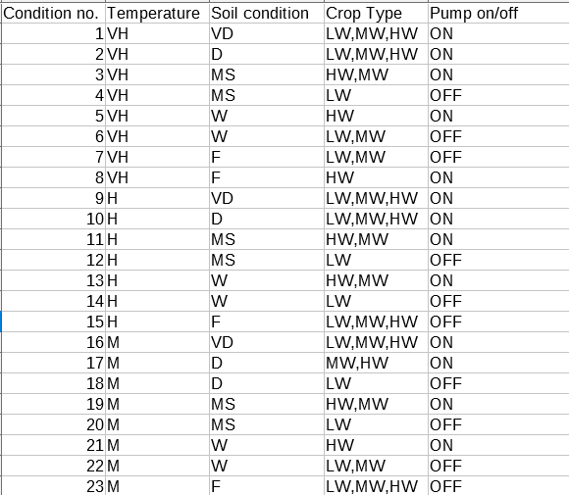

where:-

VH – Very Hot Temperature

H – Hot Temperature

M – Moderate Temperature

VD – Very Dry soil

D – Dry soil

MS – Moist soil

W – Wet soil

F – Flooded soil

LW– Low amount water requiring plants

HW– High amount water requiring plants

MW– Medium amount water requiring plants

**Sources used:-**

1. <https://www.researchgate.net/publication/>[322465889_Fuzzy_Logic_Controller_for_Effective_Irrigation_Based_on_Field_Soil_Moisture_and_Availability_of_Water](https://www.researchgate.net/publication/322465889_Fuzzy_Logic_Controller_for_Effective_Irrigation_Based_on_Field_Soil_Moisture_and_Availability_of_Water)
2. <https://www.sciencedirect.com/science/article/pii/S1474667017420970>
3. <https://hal.inria.fr/hal-01559569/document>